**DAILY ONLINE ACTIVITIES SUMMARY**

|  |  |  |  |  |  |  |  |  |
| --- | --- | --- | --- | --- | --- | --- | --- | --- |
| **Date:** | **30-06-2020** | | | | | **Name:** | **Huda Sultana** | |
| **Sem & Sec** | **8 A** | | | | | **USN:** | **4AL16CS039** | |
| **Online Test Summary** | | | | | | | | |
| **Subject** | | **-** | | | | | | |
| **Max. Marks** | | **-** | | **Score** | | | **-** | |
| **Certification Course Summary** | | | | | | | | |
| **Course** | **Amazon Elastic Container Registry.** | | | | | | | |
| **Certificate Provider** | | | **AWS** | | **Duration** | | | **30 mins** |
| **Coding Challenges** | | | | | | | | |
| **Problem Statement:**   1. **Write a C Program to sort alphabets** | | | | | | | | |
| **Status: Solved** | | | | | | | | |
| **Uploaded the report in Github** | | | | | **Yes** | | | |
| **If yes Repository name** | | | | | **Hudasulltana/online_coding** | | | |
| **Uploaded the report in slack** | | | | | **Yes** | | | |

Online Test Details:

Not Conducted

Certification Course Details:

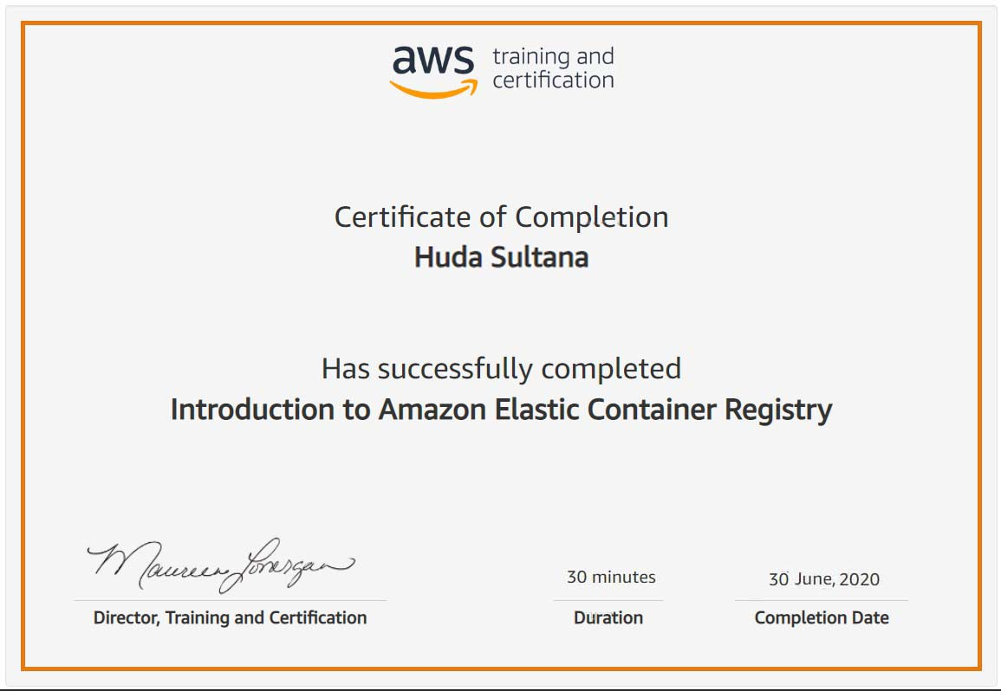

Coding Challenges Details:

**PROGRAM 1 .**

**// sorting alphabets**

**#include <stdio.h>**

**#include<string.h>**

**int main()**

**{**

**char str[25],temp,len;**

**int i, j;**

**printf("Enter the string\n");**

**scanf("%s",str);**

**printf("%s",str);**

**len=strlen(str);**

**for(i=0;i<len-1;i++)**

**{**

**for(j=i+1;j<len;j++)**

**{**

**if(str[i]>str[j])**

**{**

**temp=str[i];**

**str[i]=str[j];**

**str[j]=temp;**

**}**

**}**

**}**

**printf("\nSorted string in alphabetical order is %s",str);**

**return 0;**

**}**